Profile
Name: Arita Suguru 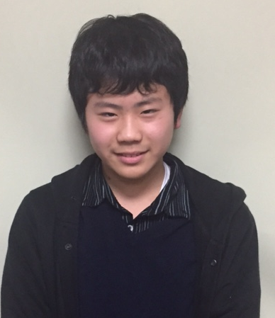
family name given name
Nationality: Japan
Birth date: 10/08/2002 (day/month/year)
Age: 14 Sex: male
School (year): 8th grade in Fuzoku Yamaguchi Junior High School

Family (name, age and occupation)
Father: Akira, 46, office worker
Mother: Junko, 46, office worker
Siblings: None

Allergy: None Religion: Buddhist

Message

Dear Family,
Thank you very much for becoming my host family.
My name is Suguru Arita. My friends call me Sugu. So please call me Sugu.
I am a member of the industrial art club.My hobby is taking pictures, and I love playing video games. I would like to visit many beautiful places in California, and take a lot of pictures.
I am very excited to go to the United States for the first time. I want to feel the difference and the similarity between America and my country. I’m looking forward to seeing you.

Sincerely,
有田 傑

